**Global Food Production Trends and Analysis: A Comprehensive Study from 1961 to 2023 Using Power BI**

**Introduction:**

ABC Company undertook a comprehensive study of global food production trends from 1961 to 2023, leveraging Power BI for insightful visualizations. The analysis encompassed key agricultural commodities, revealing that total rice production amounted to 269 billion tonnes, while wheat production reached 282 billion tonnes. The study highlighted that tea production stood at 2 billion tonnes, with Africa emerging as the leading producer of green coffee. Additionally, the research underscored a steady rise in wheat, maize, and rice production over the years, with wheat showing the most significant increase.

The project also explored the production volumes of apples, avocados, bananas, and oranges by different regions, identifying Europe and Asia as significant contributors. Maize production demonstrated consistent growth, particularly from the late 1980s onward. The study further indicated that grapes had the highest total production among fruits at 43 billion tonnes, followed by apples, bananas, and oranges. This comprehensive analysis equips ABC Company with valuable insights to better understand global food production trends, aiding strategic decision-making in the agricultural sector.

**Scenario 1: Sum of Rice Production (tonnes)**

This section prominently displays the total global rice production, amounting to 269 billion tonnes over the period from 1961 to 2023. It highlights the significant volume of rice produced, emphasizing its importance as a staple food crop worldwide.

**Scenario 2: Sum of Wheat Production (tonnes)**

Highlighting the global wheat production, this section shows a total of 282 billion tonnes produced between 1961 and 2023. This underscores wheat's crucial role in global food security and its widespread cultivation.

**Scenario 3: Sum of Tea Production (tonnes)**

 This section shows a gauge chart illustrating the total tea production, amounting to 2 billion tonnes. The visual emphasizes the scale of tea production compared to other major crops.

**Scenario 4: Sum of Coffee, Green Production (tonnes) by Entity**

A bar chart depicting the distribution of green coffee production among various entities. Africa, Asia, and America are leading producers, reflecting regional contributions to global coffee supply.

**Scenario 5: Sum of Wheat, Maize, and Rice Production (tonnes) by Year**

An area chart showing the annual production trends of wheat, maize, and rice from 1961 to 2023. It highlights the growth trajectories and fluctuations of these essential crops over the years.

**Scenario 6: Sum of Apples, Avocados, Bananas, and Oranges Production (tonnes) by Entity**

This stacked bar chart illustrates the production volumes of apples, avocados, bananas, and oranges by different entities. It highlights the diverse contributions to global fruit production.

**Scenario 7: Sum of Maize Production (tonnes) by Year**

A donut chart depicting the yearly maize production distribution across different years. It shows how maize production has evolved, with specific years highlighted for their significant contributions.

**Scenario 8: Sum of Grapes, Apples, Bananas, and Oranges Production (tonnes)**

This bar chart compares the total production volumes of grapes (43 billion tonnes), apples (39 billion tonnes), bananas (32 billion tonnes), and oranges (26 billion tonnes). It provides a comparative view of the global production scales of these popular fruits.

**Technical Architecture:**



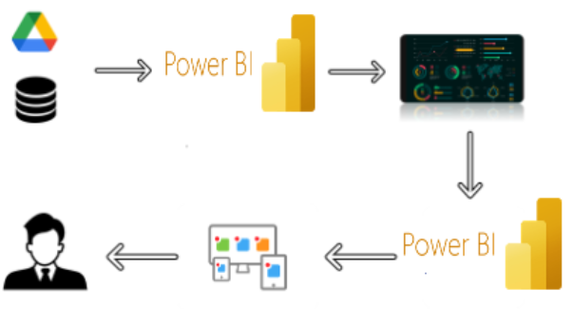

**Project Flow:**

To accomplish this, we have to complete all the activities listed below,

* Data Collection & Extraction from Database
  + Collect the dataset
  + Connect DB with Power Bi
* Data Preparation
  + Prepare the Data for Visualization
* Data Visualizations
  + No of Unique Visualizations
* Dashboard
  + Responsive and Design of Dashboard
* Report
  + Design of Report
* Performance Testing
  + Amount of Data Loaded
  + Utilization of Data Filters
  + No of Visualizations/ Graphs
* Project Demonstration & Documentation
  + Record explanation Video for project end to end solution
  + Project Documentation-Step by step project development procedure

**Milestone 1: Data Collection & Extraction from Database**

Data collection is the process of gathering and measuring information on variables of interest, in an established systematic fashion that enables one to answer stated research questions, test hypotheses, and evaluate outcomes and generate insights from the data.

**Activity 1: Collect the dataset**

Please use the link to download the dataset: [Link](https://www.kaggle.com/datasets/rafsunahmad/world-food-production)

Activity 1.1: Understand the data

Data contains all the meta information regarding the columns described in the CSV files.

**Column Description of the Dataset:**

* Entity: Represents the country or region where the food production data is recorded.
* Code: A unique identifier or code for each entity (country or region).
* Year: The specific year for which the data is recorded, ranging from 1961 to 2023.
* Apples_Production (tonnes): The total annual production of apples measured in tonnes.
* Avocados_Production (tonnes): The total annual production of avocados measured in tonnes.
* Bananas_Production (tonnes): The total annual production of bananas measured in tonnes.
* Coffee_green_Production (tonnes): The total annual production of green coffee measured in tonnes.
* Grapes_Production (tonnes): The total annual production of grapes measured in tonnes.
* Maize_Production (tonnes): The total annual production of maize measured in tonnes.
* Oranges_Production (tonnes): The total annual production of oranges measured in tonnes.
* Rice_Production (tonnes): The total annual production of rice measured in tonnes.
* Tea_Production (tonnes): The total annual production of tea measured in tonnes.
* Wheat_Production (tonnes): The total annual production of wheat measured in tonnes.

**Activity 2: Connect Data with Power BI**

With Power BI, users can seamlessly connect to a wide range of data sources, including databases, cloud services, spreadsheets, and streaming data. This capability allows organizations to consolidate disparate data sources into a single, unified platform, breaking down data silos and enabling holistic analysis.

**Data Loading video link:** [Link](https://drive.google.com/file/d/1M9tS4xI3mZC1XTVaGP95CpFeDW6GIqXl/view?usp=sharing)

**Milestone 2: Data Preparation**

Data preparation is a critical phase in the data lifecycle, encompassing activities that transform raw data into a format suitable for analysis. This multifaceted process involves several steps including data cleaning, integration, transformation, and enrichment. Data cleaning involves identifying and rectifying errors, inconsistencies, and missing values within datasets to ensure accuracy and reliability.

**Activity: Prepare the Data for Visualization**

Preparing the data for visualization involves cleaning the data to remove irrelevant or missing data, transforming the data into a format that can be easily visualized, exploring the data to identify patterns and trends, filtering the data to focus on specific subsets of data, preparing the data for visualization software, and ensuring the data is accurate and complete. This process helps to make the data easily understandable and ready for creating visualizations to gain insights into the performance and efficiency.

**Data Cleaning video link:** [Link](https://drive.google.com/file/d/1wMbAxl9mEUarfSisMe7Ee3D0oUGvpCiq/view?usp=sharing)

**Milestone 3: Data Visualization**

Data visualization is the process of creating graphical representations of data in order to help people understand and explore the information. The goal of data visualization is to make complex data sets more accessible, intuitive, and easier to interpret. By using visual elements such as charts, graphs, and maps, data visualizations can help people quickly identify patterns, trends, and outliers in the data.

**Activity 1: No of Unique Visualizations**

The World Food Production dataset allows for several unique visualizations such as bar charts, line charts, heat maps, scatter plots, pie charts, and maps. These can be used to analyze crop production trends, compare regions, track changes from 1961 to 2023, and show relationships between production, land use, and population. Such visualizations help reveal regional dominance, historical patterns, and key production insights.

**Activity 1.1: Sum of Rice Production (tonnes)**

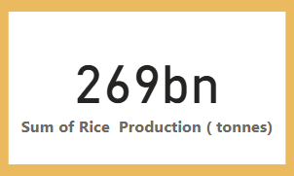

**Activity 1.2: Sum of Wheat Production (tonnes)**

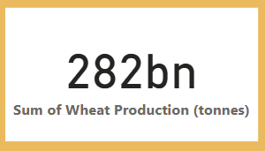

**Activity 1.3: Sum of Tea Production (tonnes)**

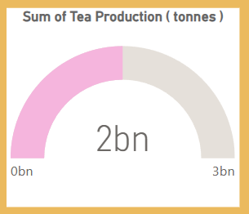

**Activity 1.4: Sum of Coffee, Green Production (tonnes) by Entity**

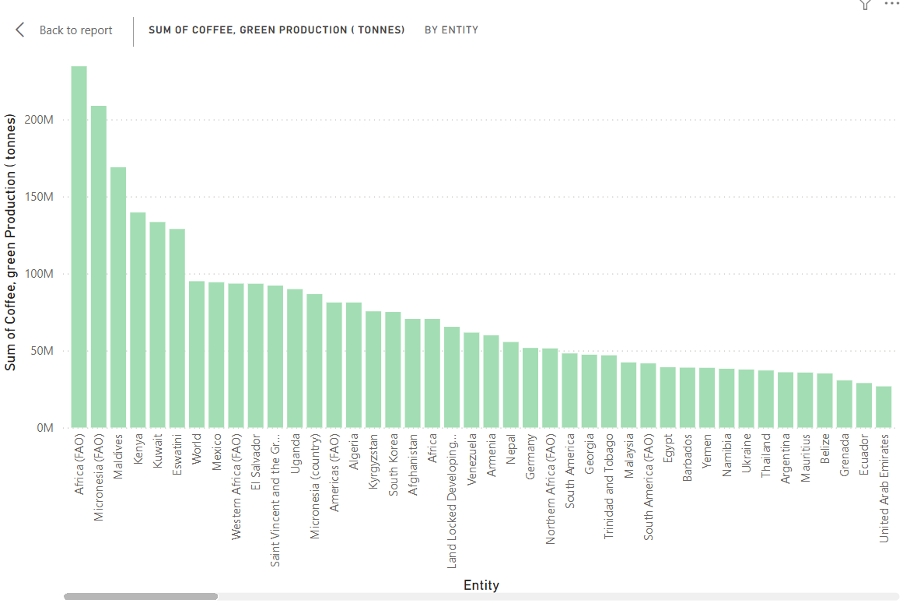

**Activity 1.5:  Sum of Wheat, Maize, and Rice Production (tonnes) by Year**

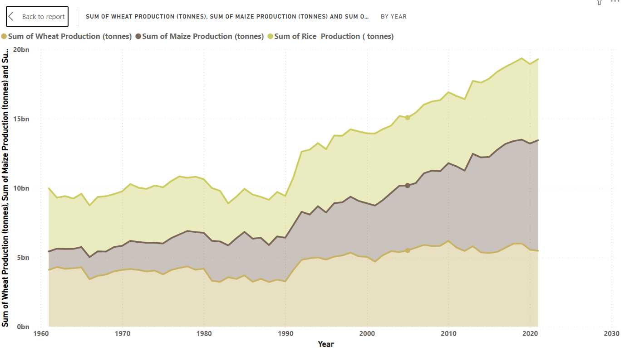

**Activity 1.6: Sum of Apples, Avocados, Bananas, and Oranges Production (tonnes) by Entity**

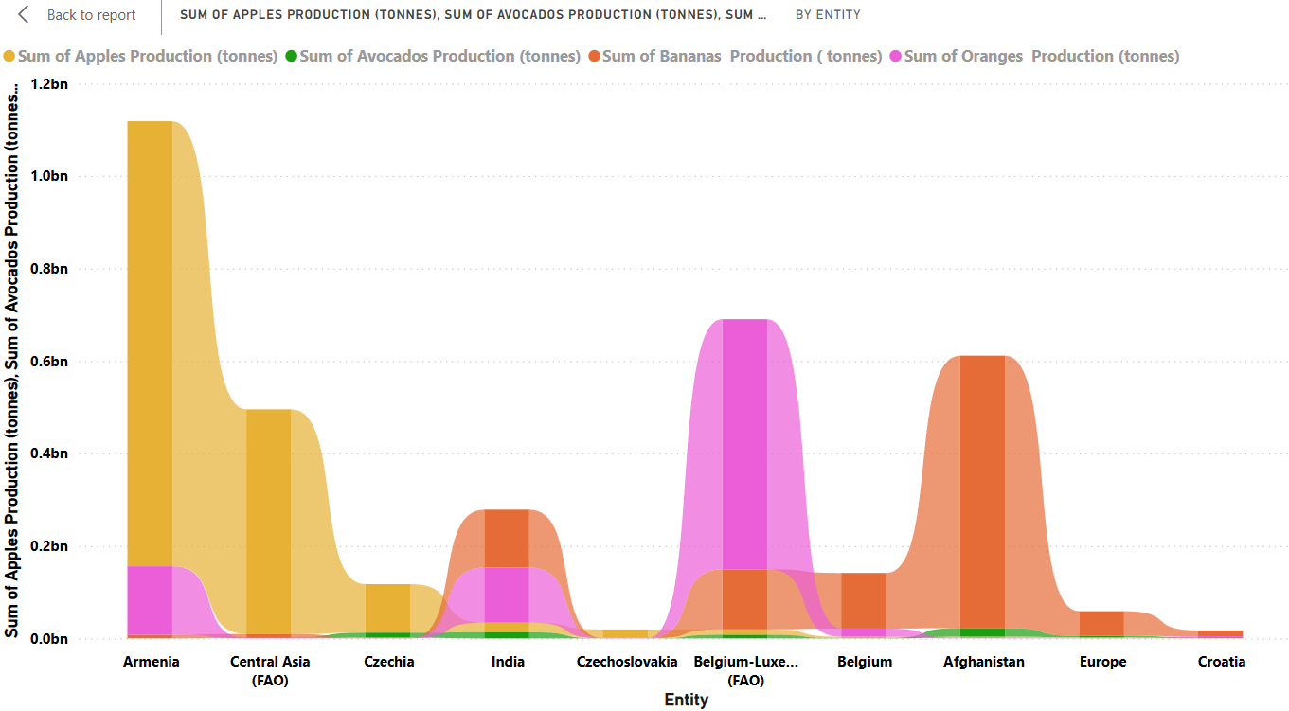

**Activity 1.7: Sum of Maize Production (tonnes) by Year**

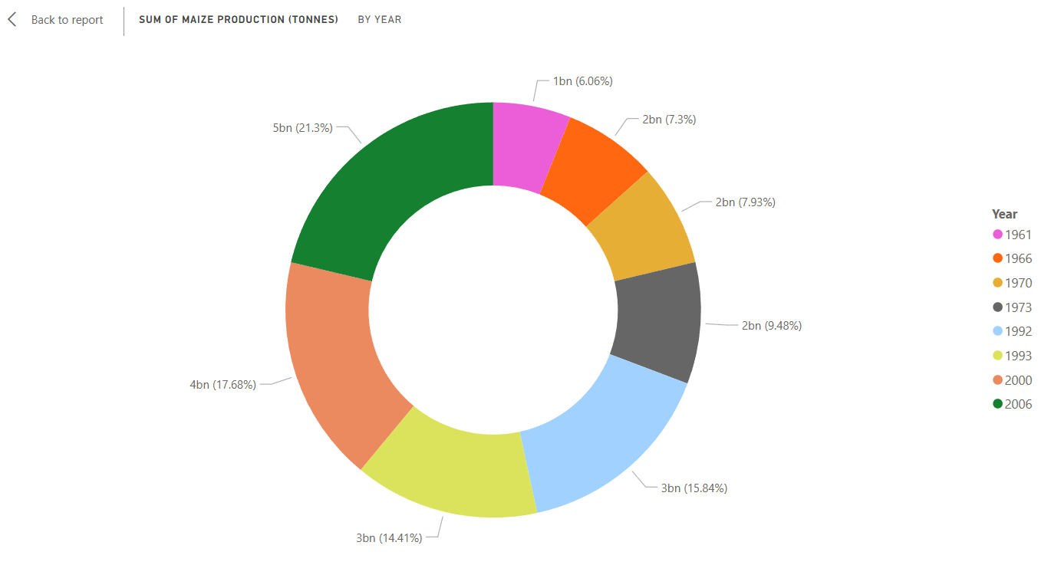

**Activity 1.8: Sum of Grapes, Apples, Bananas, and Oranges Production (tonnes)**

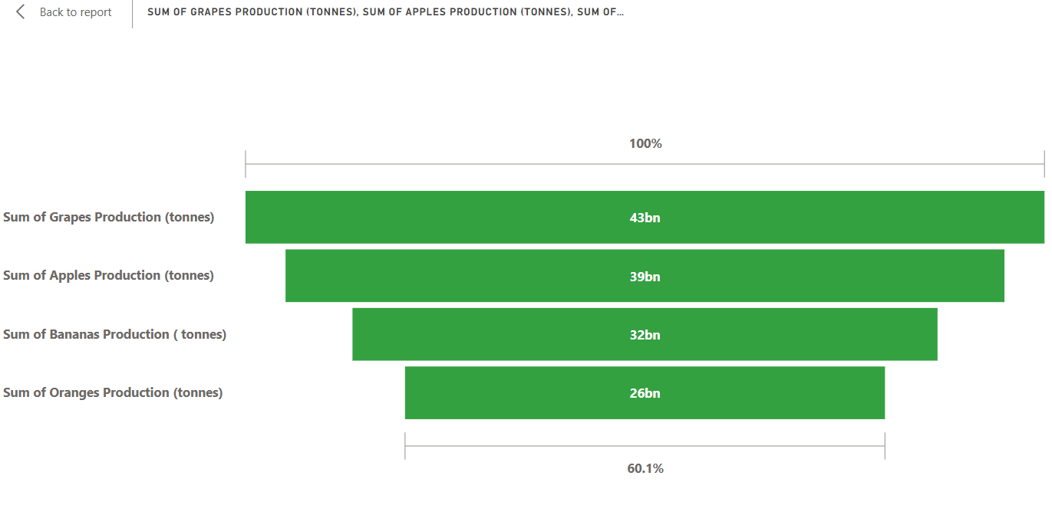

**NOTE: Video Explanations for the above Visualizations are in Dashboard and Report sections.**

**Milestone 4: Dashboard**

A dashboard is a graphical user interface (GUI) that displays information and data in an organized, easy-to-read format. Dashboards are often used to provide real-time monitoring and analysis of data, and are typically designed for a specific purpose or use case. Dashboards can be used in a variety of settings, such as business, finance, manufacturing, healthcare, and many other industries. They can be used to track key performance indicators (KPIs), monitor performance metrics, and display data in the form of charts, graphs, and tables.

**Activity: Responsive and Design of Dashboard**

The World Food Production Trends and Analysis dashboard is designed to be interactive, responsive, and easy to understand. It uses a variety of visuals like bar charts, line charts, stacked area charts, pie charts, and maps to present insights on crop production trends, regional contributions, and changes over time. Users can apply filters to explore data by year, crop type, and region, making it flexible for different analysis needs. The design ensures that data is clear, accessible, and visually appealing, helping users quickly grasp key trends in global food production.

**Dashboard explanation video link:** [Link](https://drive.google.com/file/d/12hvbhluJKTl3wzaEnTMhvRwJ5_2jHKn4/view?usp=sharing)

**Dashboard:**

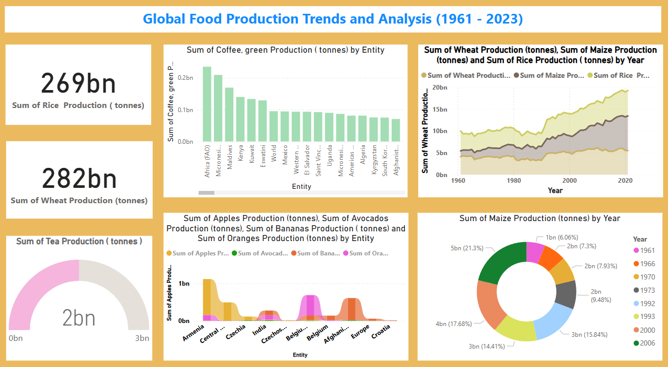

**Milestone 5: Report**

A data report is a way of presenting data and analysis in a narrative format, with the goal of making the information more engaging and easier to understand. A data story typically includes a clear introduction that sets the stage and explains the context for the data, a body that presents the data and analysis in a logical and systematic way, and a conclusion that summarizes the key findings and highlights their implications. Data Report can be told using a variety of mediums, presentations, interactive visualizations, and videos. These reports are useful for decision-makers, analysts, and stakeholders who need clear insights into global food production trends helping them with planning, analysis, and strategic decisions.

**Activity:** **Design of Report**

Designing a report in Power BI involves connecting to data sources, creating visualizations like charts and graphs, customizing their appearance and interactivity, organizing them logically on the canvas, formatting elements for consistency and clarity, and optionally creating dashboards for a summarized view. Throughout the process, it's essential to consider the audience's needs and ensure the report effectively communicates insights from the data. Finally, iterate based on feedback to continually improve the report's design and usefulness.

**Report explanation video link:** [Link](https://drive.google.com/file/d/1tf_wZpZgl5HnPiFwOv4mRc5kYLO7BWa_/view?usp=sharing)

**Report:**

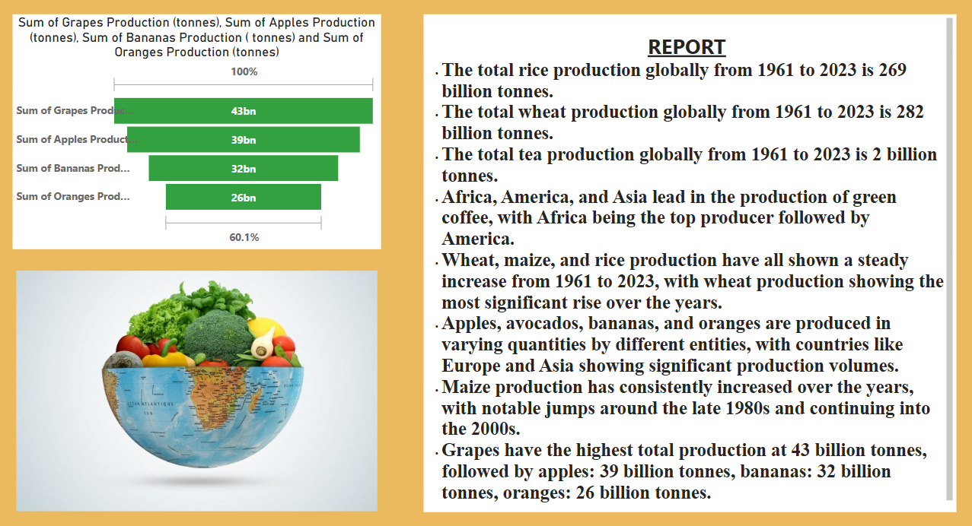

**Milestone 6: Performance Testing**

Performance testing is a crucial aspect of software development aimed at evaluating the speed, responsiveness, stability, and scalability of an application under various workload conditions. It involves simulating real-world usage scenarios to assess how the system behaves and performs under stress, peak loads, or normal conditions.

**Activity 1: Amount of Data Loaded**

"Amount of Data Loaded" refers to the quantity or volume of data that has been imported, retrieved, or loaded into a system, software application, database, or any other data storage or processing environment. It's a measure of how much data has been successfully processed and made available for analysis, manipulation, or use within the system.

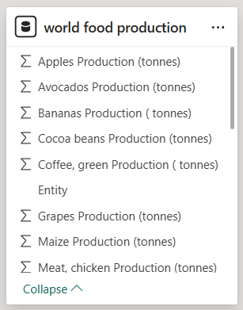

**Activity 2: Utilization of Filters**

"Utilization of Filters" refers to the application or use of filters within a system, software application, or data processing pipeline to selectively extract, manipulate, or analyze data based on specified criteria or conditions.

**Activity 2.1: Selected “Country” as a Filter**

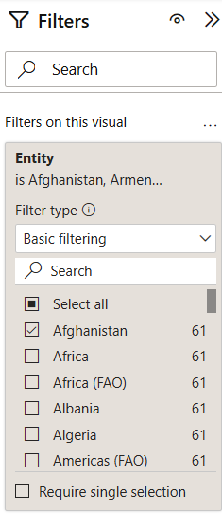

**Activity 2.2: Selected “Year” as a Filter**

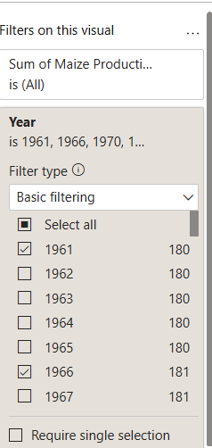

**Activity 3:** **No of Visualizations/ Graphs**

* Sum of Rice Production (tonnes)
* Sum of Wheat Production (tonnes)
* Sum of Tea Production (tonnes)
* Sum of Coffee, Green Production (tonnes) by Entity
* Sum of Wheat Production (tonnes), Maize Production (tonnes), Rice Production (tonnes) by Year
* Sum of Apples, Avocados, Bananas, Oranges Production (tonnes) by Entity
* Sum of Maize Production (tonnes) by Year
* Sum of Grapes, Apples, Bananas, Oranges Production (tonnes)

**Milestone 7: Project Demonstration & Documentation**

Creating a record explanation video for project’s end to end solution is crucial for ensuring clarity and transparency in implementation. This project demonstration video and documentation serves as a comprehensive guide, detailing every aspect of the project from inception to completion.

Drive Link: [Link](https://drive.google.com/drive/folders/1sSPxAo1xMfQ_I0MkP0U3uUYMRmCxpl3n?usp=sharing)